Intent
At Annie Lennard Primary school, we use a text-based approach to our delivery of writing. It is our intent to fully immerse pupils in a class text so that such an in-depth study can:
- Provide the stimulus for the implementation of the National Curriculum for Writing.
- Provide a seamless link between ‘readers as writers’ and ‘writers as readers’.
- Spark interest, curiosity and aspiration amongst pupils as readers and writers.
- Expose pupils who wouldn’t usually have access to a text beyond their reading band, to a text rich in vocabulary, characterisation and plot structure for example, in works of fiction; and to text rich in technical language, a variety of organisational structures and diverse and thought-provoking themes for example, in non-fiction.
- Give pupils a chance to develop culturally, emotionally, intellectually, socially and spiritually through the texts they encounter.
- To allow pupils to acquire new knowledge and to build on what they already know.
- Allow pupils to interact with a text over a sustained period of time.
- Promote reading for pleasure - a pure enjoyment of reading and a love of literature through widespread reading.
- Allow pupils to make links between texts studied.
- Expose pupils to ‘The Classics’, significant authors and new and up and coming writers and subject matter.
- Ensure a breadth of study across a range of genres.
- Broaden children’s vocabulary.
- Develop children’s linguistic knowledge, in particular of spelling, vocabulary and grammar.
- To enable children to revisit and hone skills, developing them across the year and building up their ‘writers’ toolkit’ across the primary school journey.

The grid below sets out the focus texts studied across the year.
Nursery
Nursery age:
Pupils should be taught to:
- Enjoy drawing freely.
- Add some marks to their drawings, which they give meaning to. For example: “That says mummy.”
- Make marks on their picture to stand for their name
- Writes some or all of their name.

- Use large-muscle movements to wave flags and streamers, paint and make marks.
- Are increasingly able to use and remember sequences and patterns of movements which are related to music and rhythm.
- Match their developing physical skills to tasks and activities in the setting.
- Choose the right resources to carry out their own plan.
- Use one-handed tools and equipment, for example, making snips in paper with scissors.
- Use a comfortable grip with good control when holding pens and pencils.
- Show a preference for a dominant hand.
- Be increasingly independent as they get dressed and undressed, for example, putting coats on and doing up zips.
Autumn 1 |  | Autumn 2 |  | Spring 1 | Spring 2 |  | Summer 1 |  | Summer 2
Ten Little Finger and Ten Little Toes by Mem Fox  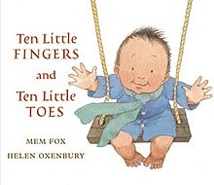  Where’s Lenny? By Ken Wilson-Max  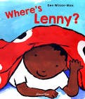  Reason for selection:  Little Wandle Introduction  Family References & Introduces number sequence  Topic – Babies  Reason for selection:  Cultural References & Introduces number sequence |  | Brown Bear, Brown Bear, What do you see? By Bill Martin Jr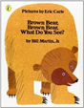  Topic – Sensory Celebrations  Reason for selection: Repetitive pattern and links to our senses.  World Nursery Rhyme Week also takes place this half term |  | Mrs Wishy-Washy's Farm by Joy Cowley & Elizabeth Fuller  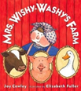  The three Little Pigs by DK and Giuseppe Di Lernia  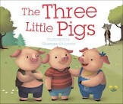  Topic – ‘Here and There’  Reason for selection:  Links to our topic and focus question – where? | The Hungry Caterpillar by Eric Carle  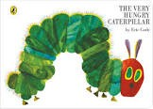  Topic – All Creatures Great and Small  Reason for Selection:  Science focus – life cycles. Introduces some non-fiction facts. |  | The Gingerbread Man by Lesley Sims  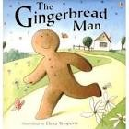  Topic – Food Glorious Food  Reason for selection:  Traditional Story linking to topic. |  | We’re Going on a Bear Hunt by Michael Rosen and Helen Oxenbury  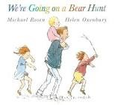  Topic – Let's go on a journey  Rosie’s walk by Pat Hutchins  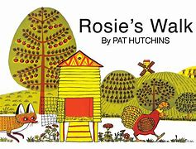  Reason for selection:  Repetitive pattern – talk for writing  Links to our topic and prepositional language
Writing opportunities:  - Squiggle dance 1a, 1b  up, down and side to side  Baseline supportive tasks:  - Making marks and giving meaning  - Painting our portrait  - Drawing our face |  | Writing opportunities:  - Squiggle dance 2a and 2b: The wiggle |  | Writing opportunities:  - Squiggle dance 3: Circles  - Drawing our family | Writing opportunities:  - Squiggle Dance and Drawing 4 – The Hump/under hump  - Introduce early name writing - ordering the letters in our name |  | Writing opportunities:  - Squiggle dance and drawing 5/6: The hook/The Spiral  - Tracing/copying the letters in our name |  | Writing opportunities:  - Squiggle dance 8/9: Zigzag  - Last piece: Drawing a picture of me for my Reception Teacher with name attached
Reception
Reception age:
Pupils should be taught to:
- Use some of their print and letter knowledge in their early writing. For example: writing a pretend shopping list that starts at the top of the page; write ‘m’ for mummy.
- Form lower case and capital letters correctly.
- Spell words by identifying the sounds and then writing the sound with letter/s.
- Write short sentences with words with known sound-letter correspondences using a capital letter and full stop.
- Re-read what they have written to check that it makes sense.

Early Learning Goal: Writing
Children at the expected level of development will:
- Write recognisable letters, most of which are correctly formed
- Spell words by identifying sounds in them and representing the sounds with a letter or letters
- Write simple phrases and sentences that can be read by others.
Autumn 1 |  | Autumn 2 |  | Spring 1 | Spring 2 |  | Summer 1 |  | Summer 2
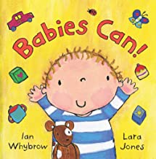  Babies can! by Ian Whybrow and Lara Jones  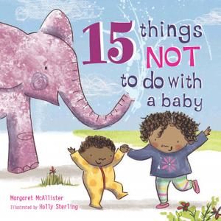  15 things not to do with a baby by Margaret McAllister |  | 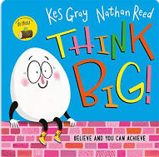  Think Big! by Kes Gray and Nathan Reed  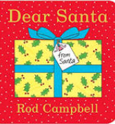  Dear Santa by Rod Campbell |  | 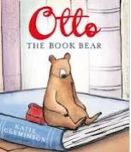  Otto the book bear by Katie Cleminson | 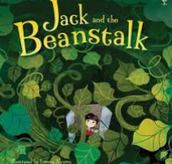  Jack and the beanstalk by Anna Milbourne and Lorena Alvarez |  | 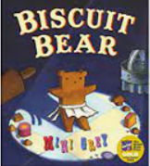  Biscuit bear by Mini Grey |  | 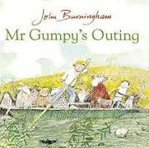  Mr Grumpy’s outing by John Burningham
Best Write – non-fiction (setting a goal for the next stage of their journey as they move to Year 1)
Audience: new Year 1 teacher
Purpose: to inform
Outcome: setting a goal
Writing opportunities:  - Orally rehearsing a sentence.  - Ordering words to make a sentence.  - Hearing and writing initial sounds in words. |  | Writing opportunities:  - Hear and write dominant sounds in words.  - Begin to write a sentence.  - Use digraphs learnt in writing  - Imaginative writing.  - Create a class book. |  | Writing opportunities:  - Emotions.  - Imaginative writing.  - Sentence structure and punctuation.  - Using digraphs and trigraphs learnt.  - Begin to chunk to write longer words. | Writing opportunities:  - Diary  - Retell of a story  - Writing sentences.  - Using full stops and finger spaces.  - Use chunking to write longer words. |  | Writing opportunities:  - Description.  - Using capital letters.  - Story recall.  - Create their own version of a story. |  | Writing opportunities:  - Writing in detail.  - Spelling of tricky words learnt.  - Story recall.  - Create own version of events.
Year 1
Writing – transcription
Spelling - see English appendix 1
Pupils should be taught to:
- spell:
- words containing each of the 40+ phonemes already taught
- common exception words
- the days of the week
- name the letters of the alphabet:
- naming the letters of the alphabet in order
- using letter names to distinguish between alternative spellings of the same sound
- add prefixes and suffixes:
- using the spelling rule for adding –s or –es as the plural marker for nouns and the third person singular marker for verbs
- using the prefix un–
- using –ing, –ed, –er and –est where no change is needed in the spelling of root words [for example, helping, helped, helper, eating, quicker, quickest]
- apply simple spelling rules and guidance, as listed in English appendix 1
- write from memory simple sentences dictated by the teacher that include words using the GPCs and common exception words taught so far
Writing – composition Pupils should be taught to:
- write sentences by:
- saying out loud what they are going to write about
- composing a sentence orally before writing it
- sequencing sentences to form short narratives
- re-reading what they have written to check that it makes sense
- discuss what they have written with the teacher or other pupils
- read their writing aloud, clearly enough to be heard by their peers and the teacher
Writing - vocabulary, grammar and punctuation
Pupils should be taught to:
- develop their understanding of the concepts set out in English appendix 2 by:
- leaving spaces between words
- joining words and joining clauses using ‘and’
- beginning to punctuate sentences using a capital letter and a full stop, question mark or exclamation mark
- using a capital letter for names of people, places, the days of the week, and the personal pronoun ‘I’
- learning the grammar for year 1 in English appendix 2
- use the grammatical terminology in English English appendix 2 in discussing their writing
Autumn 1 | Autumn 2 |  | Spring 1 |  |  | Spring 2 |  | Summer 1 |  |  | Summer 2
Super duper you by Sophy Henn 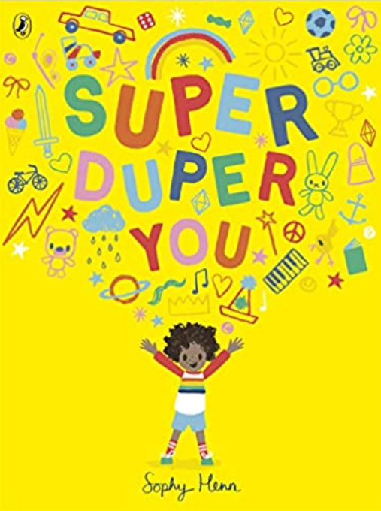 | Lost and Found by Oliver Jeffers  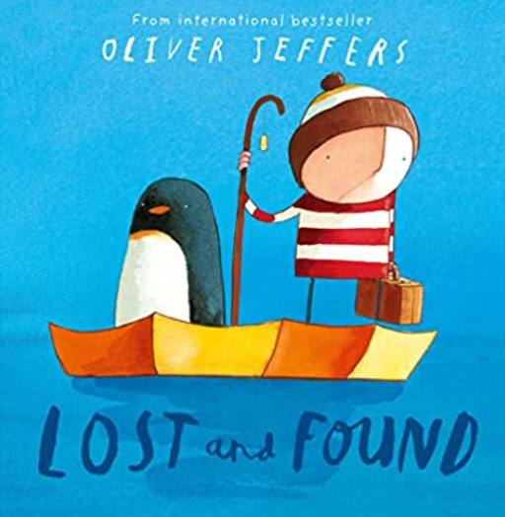 |  | Little Red Hen – Ladybird First favourite tales  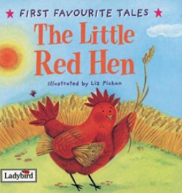 |  |  | The first slodge by Jeanne Willis & Jenni Desmond  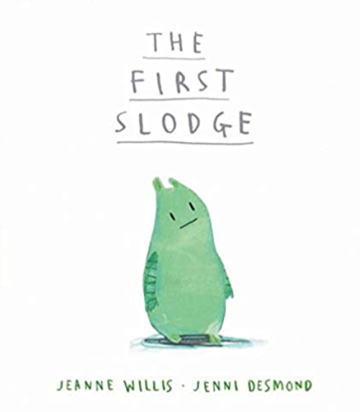 |  | Bog baby by Jeanne Wills & Gwen Millward  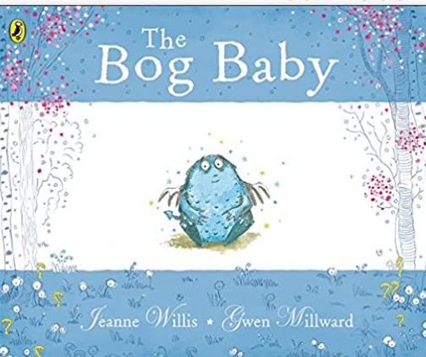 |  |  | The lighthouse keeper’s lunch by Ronda & David Armitage  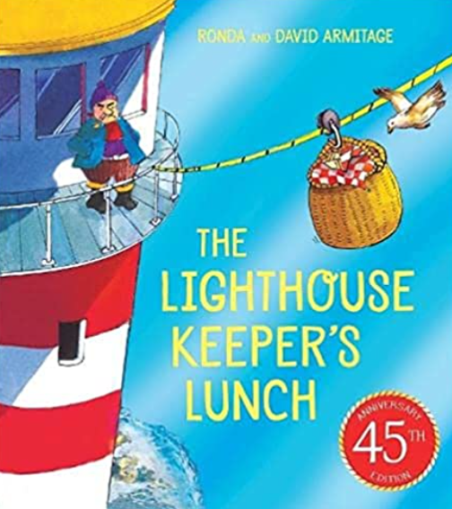
Unit outcome for best write books – non-fiction  (Have a mystery bag – share secret bag of info to work out who items in bag belong to, e.g. Miss Willetts, Miss Kershaw; chdn write sentences to describe them)  Audience: teacher/adult in setting  Purpose: to generate sentences to inform  Outcome: factual sentences about themselves | Unit outcome for best write books – narrative  (have note from penguin frozen in a block of ice, has to melt over course of day)  Audience: the penguin  Purpose: to tell him how much we’re missing him  Outcome: an informal letter |  | Unit outcome for best write books – narrative  (a re-telling of the story)  Audience: your family  Purpose: to tell them a traditional tale  Outcome: story re-tell |  |  | Unit outcome for best write books – narrative  (story innovation – imitate by changing what slodge sees, hears, eats, character she encounters)  Audience: readers  Purpose: to entertain  Outcome: story innovation |  | Unit outcome for best write books – non-fiction  (find a ‘bog baby’ on playground)  Audience: class teacher  Purpose: to tell him/her what we need to do to look after a bog baby  Outcome: instructions |  |  | Unit outcome for best write books – narrative  (setting description – lighthouse, sea, rocks)  Audience: readers  Purpose: to describe  Outcome: setting description
GPS links to be taught:  Oral rehearsal of simple sentences.  Use of personal pronoun I.  Capital letter to start sentence.  Present tense verbs (being/having/doing), e.g. I am 5; I have a brother; I play football.l  Finger spaces.  Noun phrases – adjective + noun, e.g. I have blue eyes. | GPS links to be taught:  Reinforce accurate use of capital letter for personal pronoun I.  Capital letters & full stops to start and end sentences.  Verb suffixes -ed and -ing.  Prefix un – unhappy  Adjectives/synonyms for emotions, e.g. sad/unhappy/happy /delighted/lonely etc.  Oral rehearsal of use of ‘and’ to join words and clauses  . |  | GPS links to be taught:  Capital letters and full stops to start and end sentences. Past tense verbs -ed suffix.  Noun phrases, e.g. The little red hen; the sleepy cat; the lazy dog; the noisy duck etc.  Use of ‘and’ to join clauses, e.g. She cooked the meals and washed the dishes, etc.  Reinforce use of s and -es for plural nouns, e.g. meals, dishes etc. |  |  | GPS links to be taught:  Capital letters and full stops to start and end sentences.  Use of determiners/ possessive pronouns (they don’t need to know these terms but they are integral to the story pattern!) e.g. A sunrise - my sunrise; a sunset -our sunset etc.  Use of ‘and’ to join words and clauses.  Introduce use of exclamation mark,  Use of ‘but’ to join clauses. |  | GPS links to be taught:  Capital letters and full stops to start and end sentences.  Imperative verbs.  Comparative and superlative adjectives with -est suffix, e.g. Find the softest blanket, etc.  GPS ideas for recount:  Reinforce suffixes for past tense verbs, i.e. -ed and -ing  Use of ‘but’ to join clauses, e.g. We gave him cake but..; We kept him warm but… etc.  Noun phrases, e.g. huge puddle; squelchy mud etc.  Similes, e.g. As soft as jelly, etc. |  |  | GPS links to be taught:  Capital letters and full stops to start and end sentences.  Capital letters for days of the week and for people’s names, On Monday Mrs Grinling…; on Tuesday Mr Grinling.. etc.  Use of question marks and exclamation marks.  Use of ‘and’, ‘but’, ‘so’ to join clauses.  Use of time adverbials to sequence events, e.g. Early next morning; then; in the afternoon, etc.  Noun phrases, e.g. delicious iced tea biscuits, etc.
Incidental writing along the journey  - Captions  - Labels | Incidental writing along the journey  - Setting description  - Captions  - List writing  - Thought & speech bubbles for characters |  | Incidental writing along the journey  - Story maps  - Captions  - Labels  - Descriptions |  |  | Incidental writing along the journey  - Thought bubbles – on hill (blue page) and fight when they encounter each other  - List of all the things that belong to me with ‘keep out’ title |  | Incidental writing along the journey  - Recount – finding a bog baby  - Description of the bog baby |  |  | Incidental writing along the journey  - Descriptions of items in picnic hamper  - Thought and speech bubbles for the seagulls/  Hamish the cat  - Note to lighthouse keeper of other ideas to stop the seagulls
Families, families, families by Suzanne & Max Lang 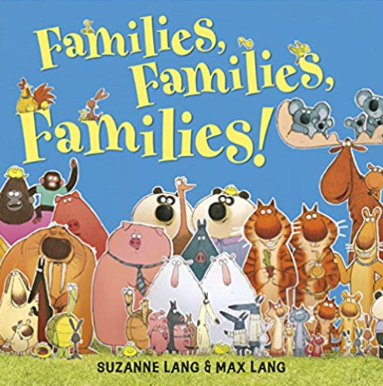 | We’re going on a lion hunt by David Axtell 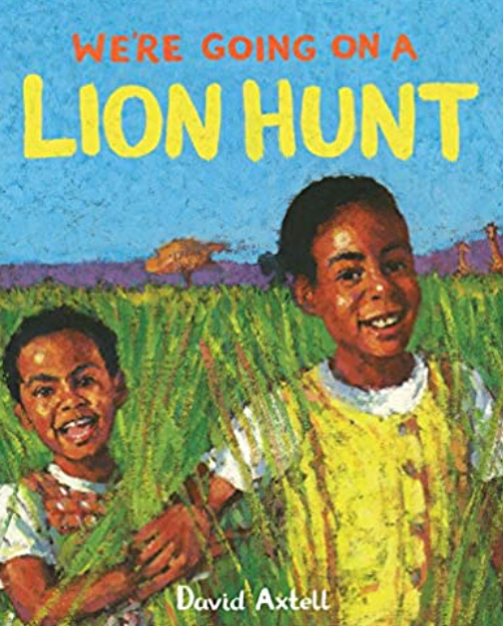 |  | Little Red Riding Hood - Ladybird first favourite tales (one version to be studied not alternatives)  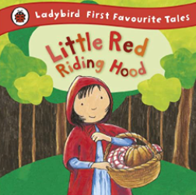 |  |  | Handa’s surprise by Eileen Browne  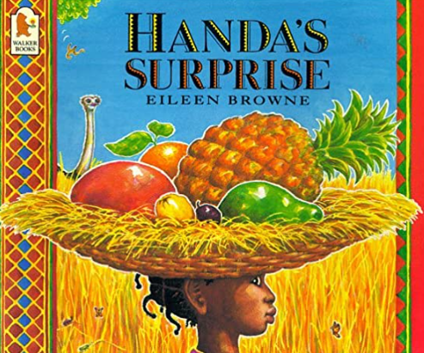
Unit outcome for best write books – non-fiction  (share pictures of familiar families to discuss, e.g. Peppa pig, Mickey & Minnie mouse)  Audience: classmates  Purpose: to tell us about your family  Outcome: sentences to inform | Unit outcome for best write books – non-fiction  (information text on one of the animals)  Audience: peers  Purpose: to inform  Outcome: simple information text |  | Unit outcome for best write books – narrative  (story innovation)  Audience: Reception teachers  Purpose: to tell them your new story  Outcome: Story innovation |  |  | Unit outcome for best write books – non-fiction  (fruit tasting in school to make a fruit salad at home)  Audience: family  Purpose: to instruct/inform  Outcome: Instructions
GPS links to be taught:  Reinforce GPS as above plus use of 3rd person, e.g. He has brown hair.  Capital letter for names of people. | GPS links to be taught:  Capital letters and full stops to start and end sentences.  Use of present tense  Subject/verb agreement, e.g. Lions have sharp teeth.  Reinforce use of ‘and’ to join ideas, e.g. Lions have sharp teeth and claws.  Noun suffix -s and -es for plurals. |  | GPS links to be taught:  Capital letters and full stops to start and end sentences. Past tense verbs -ed suffix  Use of -ing suffix  Noun phrases – sharp teeth, black eyes, dark wood etc.  Use of -er suffix, e.g. closer and closer; louder and louder.  Adverbials of time, e.g. Next morning; suddenly; then, etc.  Prepositions of place, e.g. along the path; through the wood; behind a tree, etc.  Introduce use of question mark, e.g. Where are you going? |  |  | GPS links to be taught:  Capital letters and full stops to start and end sentences.  Simple sequencing adverbials of time, e.g. first, next, after that, finally, etc.  Imperative verbs, e.g. Add, mix, chop, etc.  Reinforce use of question mark in introduction, e.g. Do you like healthy fruit?  Noun phrases, e.g. juicy apples; fresh orange juice etc.
Incidental writing along the journey  - Captions  - Labels | Incidental writing along the journey  - Descriptions  - Lists  - Captions |  | Incidental writing along the journey  - List of things in LRRH’s basket  - Letter of apology from wolf  - Instructions – how to get to Grandma’s house |  |  | Incidental writing along the journey  - Descriptions of fruit
Year 2
Writing – transcription
Spelling - see English appendix 1
Pupils should be taught to:
- spell by:
- segmenting spoken words into phonemes and representing these by graphemes, spelling many correctly
- learning new ways of spelling phonemes for which 1 or more spellings are already known, and learn some words with each spelling, including a few common homophones
- learning to spell common exception words
- learning to spell more words with contracted forms
- learning the possessive apostrophe (singular) [for example, the girl’s book]
- distinguishing between homophones and near-homophones
- add suffixes to spell longer words including –ment, –ness, –ful, –less, –ly
- apply spelling rules and guidance, as listed in English appendix 1
- write from memory simple sentences dictated by the teacher that include words using the GPCs, common exception words and punctuation taught so far
Writing - composition
Pupils should be taught to:
- develop positive attitudes towards and stamina for writing by:
- writing narratives about personal experiences and those of others (real and fictional)
- writing about real events
- writing poetry
- writing for different purposes
- consider what they are going to write before beginning by:
- planning or saying out loud what they are going to write about
- writing down ideas and/or key words, including new vocabulary
- encapsulating what they want to say, sentence by sentence
- make simple additions, revisions and corrections to their own writing by:
- evaluating their writing with the teacher and other pupils
- rereading to check that their writing makes sense and that verbs to indicate time are used correctly and consistently, including verbs in the continuous form
- proofreading to check for errors in spelling, grammar and punctuation (for example, ends of sentences punctuated correctly)
- read aloud what they have written with appropriate intonation to make the meaning clear
Writing - vocabulary, grammar and punctuation
Pupils should be taught to:
- develop their understanding of the concepts set out in English appendix 2 by:
- learning how to use both familiar and new punctuation correctly - see English appendix 2, including full stops, capital letters, exclamation marks, question marks, commas for lists and apostrophes for contracted forms and the possessive (singular)
- learn how to use:
- sentences with different forms: statement, question, exclamation, command
- expanded noun phrases to describe and specify [for example, the blue butterfly]
- the present and past tenses correctly and consistently, including the progressive form
- subordination (using when, if, that, or because) and co-ordination (using or, and, or but)
- the grammar for year 2 in English appendix 2
- some features of written Standard English
- use and understand the grammatical terminology in English appendix 2 in discussing their writing
Autumn 1 | Autumn 2 |  | Spring 1 |  |  | Spring 2 |  | Summer 1 |  |  | Summer 2
Hansel & Gretel by Antony Browne  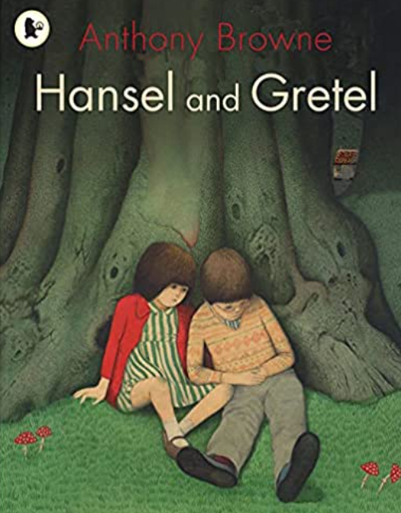 | The Polar Express by Chris Van Allsburg   |  | Vlad and the Great Fire of London – Kate Cunningham  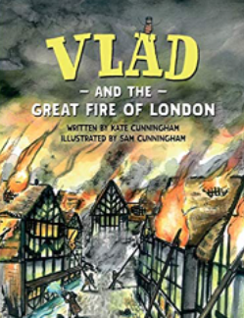 |  |  | Grandad’s island by Benji Davies  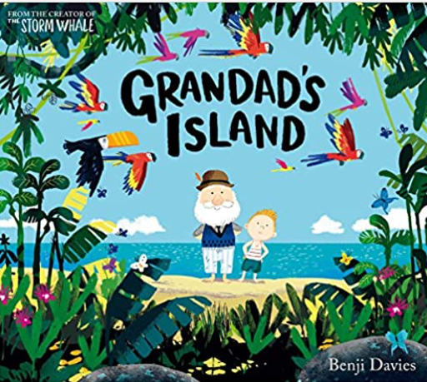 |  | The selfish giant by Oscar Wilde – illustrated version – Alexis Deacon  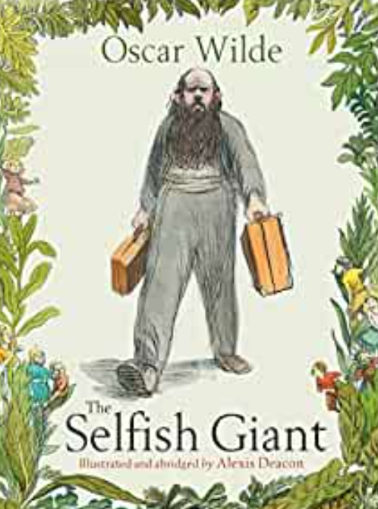 |  |  | Man on the moon by Simon Bartram 
Unit outcome for best write books –narrative  (embellished re-tell – setting and character description – up to witch appearing)  Audience: children  Purpose: to entertain  Outcome: embellished re-telling | Unit outcome for best write books –narrative  (setting description – woven through narrative, seen through eyes of character)  Audience: reader  Purpose: to describe  Outcome: description of journey to the pole |  | Unit outcome for best write books –report  (report on Great Fire of London)  Audience: young readers  Purpose: to inform  Outcome: non chronological report |  |  | Unit outcome for best write books –narrative  (sea – storm scene – arrival on island)  Audience: reader  Purpose: to describe  Outcome: setting description |  | Unit outcome for best write books –narrative  (characterisation – the giant (another creature has the garden – child not allowed to go in, winter comes – use same plot model)  Audience: readers  Purpose: to entertain  Outcome: new event |  |  | Unit outcome for best write books – recount  (diary entry – What a day! I had to keep those guests amused by doing my saumersaults…)  Audience: fellow astronauts  Purpose: to recount  Outcome: diary entry
GPS links to be taught:  Reinforce consistently accurate use of punctuation from Y1, i.e. capital letters to start sentences and for proper nouns; full stops to end sentences; use of ? and !  Noun phrases, e.g. withered tree; black eyes like marbles  Past tense verbs  Use of wider range of adverbials for time, e.g. At daybreak; At midday; and place (where?), e.g. deep in the forest.  Reinforce use of and, but, so to join clauses and encourage use of wider range of conjunctions, e.g. when, as, because | GPS links to be taught:  Reinforce consistently accurate use of punctuation from Y1, i.e. capital letters to start sentences and for proper nouns; full stops to end sentences; use of ? and !  Noun phrases with similes, e.g. hot cocoa as thick and rich as melted chocolate bars.  Powerful verb choices, e.g. flickered, raced, thundered, pranced, paced, marched, etc.  Expand range of adverbials for place (where?), e.g. through forests; over peaks.  Use of commas to separate items in a list, e.g. hot chocolate, marshmallows and whipped cream.  Use of -ly adverbs, e.g. cautiously, quietly, quickly  Reinforce use of and, but, so to join clauses and encourage use of wider range of conjunctions, e.g. when, as, because |  | GPS links to be taught:  Reinforce consistently accurate use of punctuation from Y1, i.e. capital letters to start sentences and for proper nouns; full stops to end sentences; use of ? and !  Use of commas to separate items in a list, e.g. they buried wine, cheese and valuables  Noun phrases for effect, e.g. raging inferno  Use of past tense, including past progressive, e.g. the fire was spreading out of control...  Use of wider range of adverbials for time, e.g. By evening...two days later and place (where?), e.g. from roof to roof; across the river  Reinforce use of and, but, so to join clauses and encourage use of wider range of conjunctions, e.g. when, if, as, because  Adding suffixes, e.g. helpless; careless; grateful; thankful |  |  | GPS links to be taught:  Reinforce consistently accurate use of punctuation from Y1, i.e. capital letters to start sentences and for proper nouns; full stops to end sentences; use of ? and !  Use of commas to separate items in a list, e.g. They saw parrots, macaws and monkeys.  Use of precise nouns, e.g. vines, shack, macaws, etc.  Noun phrases, e.g. enormous waves  Powerful verbs, e.g. lurched, boomed, chugged, churned, prised etc.  Use of adverbials for place (where?), e.g. in the distance; on the horizon; above the boat; across the sky  Reinforce use of and, but, so to join clauses and encourage use of wider range of conjunctions, e.g. when, if, as, because  Adding suffixes, e.g. amazement; beautiful;  Comparative and superlative adjectives, e.g. the waves were higher than the boat; the angriest sea he had ever seen. |  | GPS links to be taught:  Reinforce consistently accurate use of punctuation from Y1, i.e. capital letters to start sentences and for proper nouns; full stops to end sentences; use of ? and !  Use of commas to separate items in a list, e.g. Sparrows, robins and magpies hopped from branch-to-branch  Precise nouns, e.g. daffodils, tulips, snowdrops  Expanded noun phrases, e.g. a menacing growl; a huge toothy smile etc.  Use of suffixes, e.g. wonderful, beautiful, amazement, abruptly, carefully etc. |  |  | GPS links to be taught:  Reinforce consistently accurate use of punctuation from Y1, i.e. capital letters to start sentences and for proper nouns; full stops to end sentences; use of ? and !  Exclamatory sentence, e.g. What a day I’ve had!  Use of first person  Range of verb tenses, including past progressive, e.g. As I was cleaning the crater, I thought I heard…  Reinforce use of and, but, so to join clauses and encourage use of wider range of conjunctions, e.g. when, if, as, because  Range of adverbials of time to sequence events.  Range of adverbials of place (where?), e.g. in the craters; on the surface; across the night sky etc.  Range of suffixes, e.g. amusement, thoroughly, thoughtless, colourful  Use of apostrophe for contracted form, e.g. I can’t believe that people think aliens are real!  Use of compound words, e.g. moonlight, sunlight
Incidental writing along the journey  - Wanted poster – for witch | Unit outcome for best write books – narrative  (first person recount of start of the book up to point where he boards the train)  Audience: a friend  Purpose: to recount  Outcome: diary entry |  | Unit outcome for best write books – recount  (Samuel Pepys/somebody else)  Audience: for future generations  Purpose: to recount  Outcome: diary entry |  |  | Unit outcome for best write books – letter  (letter to boy from Grandad or vice versa – hot seat first)  Audience: boy/Grandad  Purpose: to empathise  Outcome: a letter |  | Incidental writing along the journey  - Letter – from child to giant – let us play in your garden |  |  | Incidental writing along the journey  - Job application – responding to job advert to become an astronaut  - Joke book – question marks and exclamation marks, capital letters for proper nouns  - Invitation/  - poster/menu - for alien moon party  - Aliens who’s who? – character profile  - Postcard – from moon tourist
 | GPS links to be taught:  As above plus…  Use of past tense verbs including past progressive, e.g. I was dreaming of Christmas when suddenly I…  Use of apostrophe for contracted form, e.g. I couldn’t believe my eyes… |  | GPS links to be taught:  As above plus…  Use of first person I  Use of past tense verbs including past progressive, e.g. I was digging a hole for my valuables when I felt.. …  Use of apostrophe for contracted form, e.g. I couldn’t believe how quickly the fire was travelling… |  |  | GPS links to be taught:  As above plus…  Use of first person I  Use of range of verb tenses including present progressive, e.g. As I’m writing this, I ‘m remembering… …  Use of apostrophe for contracted form, e.g. I’ll never forget you; I won’t … etc.  Wider range of suffixes, e.g saddest, helpless, wonderful, happiness etc. |  | GPS links to be taught:  As above plus…  Use of first person I  Use of range of verb tenses including present progressive, e.g. I am writing to ask/persuade…  NB: Avoid contracted form if this is a formal letter.  Comparative and superlative adjectives, e.g. Your garden is the most beautiful in the neighbourhood; Your garden is the largest on the road; Your garden is bigger than ours, etc.
 |  |  | Unit outcome for best write books – recount  (recount of trip/experience/event)  Audience: dependant on what is chosen  Purpose: to recount  Outcome: dependant on what is chosen |  |  | Unit outcome for best write books – Instructions  (den building/shelter/camp fire – practical – link to trip)  Audience: peers  Purpose: to instruct/inform  Outcome: children’s survival guide (real life events) |  | Unit outcome for best write books – poem  (to giant based on Christina Rossetti – What is pink? A rose is pink… etc)  Audience: peers  Purpose: to describe  Outcome: a descriptive poem
 |  |  | GPS links to be taught:  As above plus…  Wider range of appropriate adverbials of time to sequence events |  |  | GPS links to be taught:  Imperative verbs  Time adverbials to sequence steps, e.g. first, next, after that, finally  Use of -ly adverbs, e.g. carefully; finely  Use of bullet points to list equipment needed  Noun phrases, e.g. dry wood; a sharp saw etc.  Range of conjunctions including and, but, so, when, because, if etc.  Adverbials of place (where?), e.g. in a clearing; across the middle etc. |  | GPS links to be taught:  Use of question marks  Present tense verbs  Expanded noun phrases chosen for effect  Similes
Year 3 & 4
Writing – transcription
Spelling - see English appendix 1
Pupils should be taught to:
- use further prefixes and suffixes and understand how to add them - see English appendix 1
- spell further homophones
- spell words that are often misspelt - see English appendix 1
- place the possessive apostrophe accurately in words with regular plurals [for example, girls’, boys’] and in words with irregular plurals [for example, children’s]
- use the first 2 or 3 letters of a word to check its spelling in a dictionary
- write from memory simple sentences, dictated by the teacher, that include words and punctuation taught so far
Writing - composition
Pupils should be taught to:
- plan their writing by:
- discussing writing similar to that which they are planning to write in order to understand and learn from its structure, vocabulary and grammar
- discussing and recording ideas
- draft and write by:
- composing and rehearsing sentences orally (including dialogue), progressively building a varied and rich vocabulary and an increasing range of sentence structures English appendix 2
- organising paragraphs around a theme
- in narratives, creating settings, characters and plot
- in non-narrative material, using simple organisational devices [for example, headings and sub-headings]
- evaluate and edit by:
- assessing the effectiveness of their own and others’ writing and suggesting improvements
- proposing changes to grammar and vocabulary to improve consistency, including the accurate use of pronouns in sentences
- proofread for spelling and punctuation errors
- read their own writing aloud to a group or the whole class, using appropriate intonation and controlling the tone and volume so that the meaning is clear
Writing - vocabulary, grammar and punctuation
Pupils should be taught to:
- develop their understanding of the concepts set out in English appendix 2 by:
- extending the range of sentences with more than one clause by using a wider range of conjunctions, including: when, if, because, although
- using the present perfect form of verbs in contrast to the past tense
- choosing nouns or pronouns appropriately for clarity and cohesion and to avoid repetition
- using conjunctions, adverbs and prepositions to express time and cause
- using fronted adverbials
- learning the grammar for years 3 and 4 in [English appendix 2]/government/uploads/system/uploads/attachment_data/file/335190/English_Appendix_2_-_Vocabulary_grammar_and_punctuation.pdf)
- indicate grammatical and other features by:
- using commas after fronted adverbials
- indicating possession by using the possessive apostrophe with plural nouns
- using and punctuating direct speech
- use and understand the grammatical terminology in English appendix 2 accurately and appropriately when discussing their writing and reading
Year 3
Autumn 1 | Autumn 2 |  | Spring 1 |  |  | Spring 2 |  | Summer 1 |  |  | Summer 2
Stone Age Boy by Satoshi Kimamura  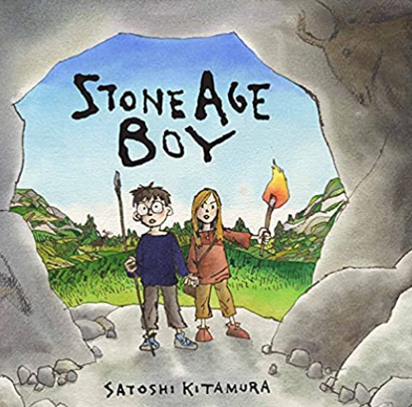 | The Egg by MP Robertson  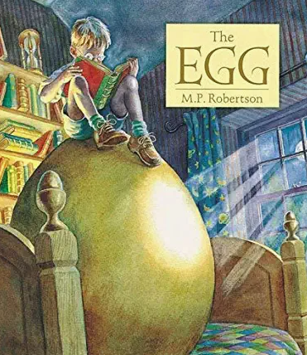 |  | Escape from Pompeii – Christina Balit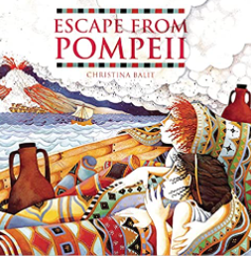 |  |  | Iron Man by Ted Hughes  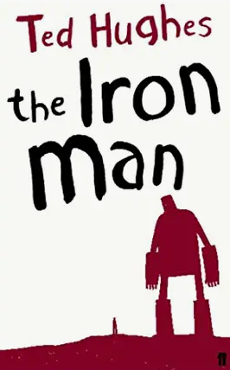 |  | This morning I met a whale by Michael Morpurgo  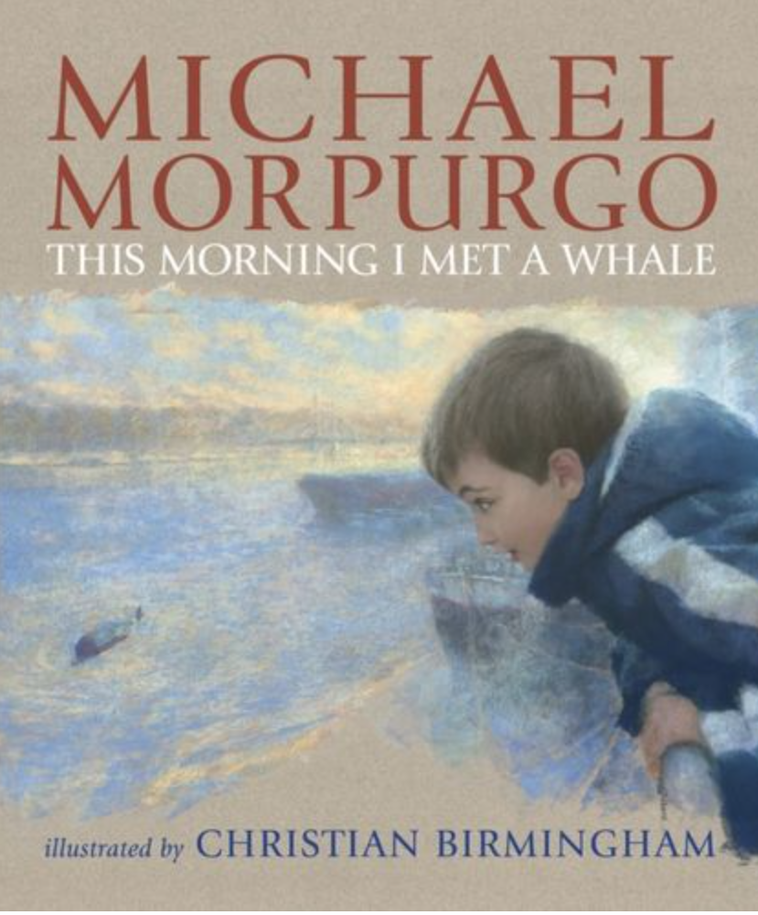 |  |  | The Promise by Nicola Davis  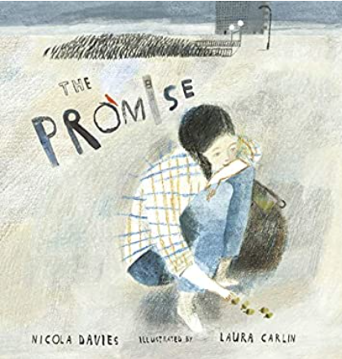
Unit outcome for best write books –narrative  (characterisation and setting–meet another character other than bear in the cave)  Audience: young readers  Purpose: to entertain  Outcome: story innovation | Unit outcome for best write books –narrative  (characterisation and setting–the dragon & the cave)  Audience: young readers  Purpose: to entertain  Outcome: a section from the story |  | Unit outcome for best write books –narrative  (action scene fleeing from a disaster –e.g. two characters on holiday in Sisley, everything well, disaster occurs, helicopter arrives, all well)  Audience: young readers  Purpose: to entertain  Outcome: short story |  |  | Unit outcome for best write books –recount  (opening–change to something else stood on the cliff – teach various ways of opening a story, e.g. dialogue, setting description, action etc – chdn choose a way to write their opening, then try another.)  Audience: young readers  Purpose: to entertain  Outcome: alternative openings |  | Unit outcome for best write books –recount  (diary entry from Michael’s point of view – why won’t anyone believe me…?)  Audience: a friend  Purpose: to recount  Outcome: diary entry |  |  | Unit outcome for best write books –instructional text  (link to Guided Reading text – Killer plants – design own killer plant – instructions for planting and looking after)  Audience: peers  Purpose: to instruct/inform  Outcome: manual
GPS links to be taught:  Reinforce consistently accurate use of punctuation from KS1, i.e. capital letters to start sentences and for proper nouns; full stops to end sentences; use of ? and !; Reinforce use of commas for lists, e.g. red, brown and orange animal skins.  Introduce rule for a/an determiners, e.g. An enormous bear emerged from the shadows of the cave.  Expanded noun phrases, e.g. a fierce, menacing growl; a huge, toothy smile  Use of suffixes, e.g. wonderful, beautiful, amazement, gingerly, carefully etc.  Use of wider range of conjunctions, e.g. when, if, because, although, until, so, but, as  Use of adverbs to express time, e.g. soon, later, next, suddenly  Prepositions to express time, place, e.g. Before dawn…; From that day forward…; in the shadows | GPS links to be taught:  Reinforce consistently accurate use of punctuation from KS1, i.e. capital letters to start sentences and for proper nouns; full stops to end sentences; use of ? and !; use of commas for lists.  As in previous narratives plus…  Reinforce accurate use of punctuation for dialogue from autumn 1 and include wider range of speech tags, e.g. whispered, gasped, etc. (but do not ban ‘said’!)  Reinforce rule for a/an determiners, e.g. An incredible sight…  Expanded noun phrases, e.g. shimmering, green scales….curved, golden horns (but not always 2 adjectives before every noun!)  Use of suffixes, e.g. happiness, greatest, taller, unfortunately, etc.  Use of wider range of conjunctions, e.g. when, if, because, although, so, but, as and reinforce conjunctions of time, e.g. He waited until it began to crack… After he had read it a bedtime story, George…  Use of adverbs to express time, e.g. Early one sunny morning, Three days later..  Expand adverbials of place, e.g. across vast plains…over the deepest oceans |  | GPS links to be taught: Reinforce consistently accurate use of punctuation from KS1, i.e. capital letters to start sentences and for proper nouns; full stops to end sentences; use of ? and !; use of commas for lists.  As in previous narratives plus…  Reinforce accurate use of punctuation for dialogue from autumn term and include wider range of speech tags with an action to show characterisation, e.g. “Run!” he shouted, grabbing her hand.  Continue to reinforce accurate application of rule for a/an determiners.  Expanded noun phrases with some imagery, e.g. a blanket of molten lava  Consolidate use of verb forms from previous years, e.g. As they were racing towards the harbour, the roar grew louder and louder.  Choose powerful verbs for effect, e.g. ripped through the sky  Use of wider range of conjunctions including those for time, e.g. Before they could react…They ran and ran until they were gasping for breath…  Use adverbials of time, manner and place – including as fronted adverbials, e.g. Without a second’s hesitation, he…; with panic rising in his chest, he..…; on the far side of the boat  Variation in sentence length for effect, e.g. sentence of 3 for pace; short sentence. |  |  | GPS links to be taught: Reinforce consistently accurate use of punctuation from KS1, i.e. capital letters to start sentences and for proper nouns; full stops to end sentences; use of ? and !; use of commas for lists.  As in previous narratives plus…  Reinforce accurate use of punctuation for dialogue from previous narratives and include wider range of speech tags with an action to show characterisation, e.g. “What is that?” he whispered, his eyes widening in horror.  Expanded noun phrases, including use of precise nouns, e.g. headland, dunes, cliff, gulls etc.  Appropriate use of imagery to build a picture for the reader, e.g. a curtain of icy rain |  | GPS links to be taught: Reinforce consistently accurate use of punctuation from KS1, i.e. capital letters to start sentences and for proper nouns; full stops to end sentences; use of ? and !; use of commas for lists.  Build on skills used in diary recounts previously, e.g.  Use adverbials of time, manner and place, e.g. Last Thursday morning…; with a smile on his face…; on the far side of the river bank  Consolidate use of the present perfect tense from Y3, e.g. Michael has walked this path for many years as part of his journey to school.  Encourage use of precise nouns to build a picture of setting for the reader, e.g. herons, cormorants etc. instead of birds. |  |  | GPS links to be taught: Reinforce consistently accurate use of punctuation from KS1, i.e. capital letters to start sentences and for proper nouns; full stops to end sentences; use of ? and !; use of commas for lists.  Build on skills taught previously plus…  Use of adverbs to express time, e.g. firstly, secondly, finally  Prepositions to express time, place, e.g. After lunch…; Before bedtime…; in the pot  Consolidate accurate and appropriate use of tenses taught so far, e.g. simple past and present; use of present progressive, e.g. As you are polishing the leaves, be careful to… ; Use of imperative verbs, e.g. Polish the leaves in a clockwise direction. Use of present perfect, e.g. When you have finished…  Consolidate accurate and appropriate use of apostrophe from KS1, e.g. for possession: The Mothkiller’s flower is poisonous so…
Incidental writing along the journey  - Dialogue - Boy meets Om, part where she’s pointing at him – fill in speech bubbles, ‘burst’ them and write dialogue between the two characters.  - Diary entry – when Om takes the boy hunting | Unit outcome for best write books – recount  (diary entry in role as boy – bit where he’s in bed and devastated as dragon has gone – journey through night sky, use clips from The Snowman & Gorilla as stimulus)  Audience: young readers  Purpose: to recount and describe  Outcome: diary entry |  | Unit outcome for best write books – poem  (shape/list poem on natural disaster, e.g. fire, volcano etc – focus on vocabulary- natural disaster vocab)  Audience: young readers  Purpose: to describe  Outcome: poem |  |  | Unit outcome for best write books – recount  (news broadcast – farmers reporting that their tractors have chunks of metal taken out od them etc…)  Audience: general public  Purpose: to inform  Outcome: news broadcast |  | Incidental writing along the journey  - Dialogue |  |  | Unit outcome for best write books – explanation  (life cycles of a plant – dandelion)  Audience: readers  Purpose: to explain  Outcome: simple explanation
GPS links to be taught:  As above plus..  Introduce use of inverted commas for speech and convention of new speaker, new line, e.g.  “Who are you?” I asked.  “My name is Om,” she replied.  Reinforce consistent use of first person for diary entry.  Accurate use of past tense including past progressive from KS1, e.g. As I was studying them, I slowly became aware of…  Use of contracted form with accurate use of apostrophe. | GPS links to be taught:  As above plus..  Wider range of verb tenses to show progression in skills from diary in autumn 1, e.g. Present perfect: I have searched and searched for my dragon but I can’t find him.  Wider range of adverbials of time, manner and place from autumn 1, e.g. As the hours passed…As darkness fell…quick as a flash…up and over huge mountains |  | GPS links to be taught:  Choose powerful vocabulary for effect, including imagery and onomatopoeia, e.g. balls of flame like comets |  |  | GPS links to be taught:  Journalistic language choices for effect, e.g. powerful verbs. |  | GPS links to be taught:  Reinforce accurate use of punctuation for dialogue from previous narratives and include wider range of speech tags with an action to show characterisation, e.g. “It can’t have been a whale!” he sneered, smirking and pointing at Michael. |  |  | GPS links to be taught:  Build on skills taught previously plus…  Use of present tense and third person to give text an impersonal and objective voice, e.g. Dandelions are found…  Use conjunctions for:  -Time and sequence: then, before, when etc. First, second, etc.  - To sequence information leading towards a conclusion.  -Cause and effect to link reasons and conclusions: so, so that, because, in order to; due to; This allows; consequently; Therefore etc.  Use of subject-specific nouns, e.g. stem, root etc.
Unit outcome for best write books – report  (non-chronological report on Stone Age)  Audience: young readers  Purpose: to inform  Outcome: a pull out for the back of the book | Unit outcome for best write books – report  (non-chronological report on own made up dragons – see Pie Corbett stuff)  Audience: people interested in dragons  Purpose: to inform  Outcome: a leaflet/non-chronological report |  |  |  |  | Unit outcome for best write books – persuasion  (letter of apology from H to Iron Man for the fact that he’s tormenting him)  Audience: Iron Man  Purpose: to persuade  Outcome: letter |  | Unit outcome for best write books – persuasion  (letter to Greenpeace – save the whales!)  Audience: Greenpeace  Purpose: to persuade  Outcome: letter |  |  | Unit outcome for best write books – poem  (contrast poem – one verse = city – ugly and barren; one verse = the beautiful landscape – focus on precise nouns)  Audience: young readers  Purpose: to describe  Outcome: descriptive poem
GPS links to be taught:  As above where appropriate plus…  Consistent use of 3rd person  Consistent use of past tense (for nc report linked to the past)  Expanded noun phrases, e.g. shoes made from animal hide  Fronted adverbials of time, e.g. Long, long ago…. | GPS links to be taught:  As above where appropriate plus…  Maintain consistent use 3rd person present tense  Use of comparatives and superlatives, e.g. bigger than…the strongest dragon  Subject specific vocabulary used in noun phrases, e.g. curved talons…a powerful tail…flared nostrils |  |  |  |  | GPS links to be taught:  Build on skills taught previously plus…  Emotive language, e.g. I am truly sorry…unforgivable etc.  Modal verbs (Y5 objective but required for persuasive writing), e.g. I would like to apologise.  If formal letter, avoid contracted form. |  | GPS links to be taught:  Build on skills taught previously plus…  Emotive language choices, e.g. devastating, disastrous, a tragedy etc.  Modal verbs (Y5 objective but required for persuasive writing), e.g. This should be stopped.  Range of sentence types, including rhetorical questions and commands, e.g. Surely this cannot be right? We must act now!  Wider range of cohesive devices, e.g. In addition…furthermore..as a result..I strongly believe that… etc. |  |  | GPS links to be taught:  Use of powerful language for effect, including precise nouns, e.g. daffodils, tulips etc. instead of flowers.  Appropriate use of imagery, e.g. Ground covered with petals like a carpet of confetti
Year 4
Autumn 1 | Autumn 2 |  | Spring 1 |  |  | Spring 2 |  | Summer 1 |  |  | Summer 2
The Orchard book of Greek myths by Geraldine McCaughrean  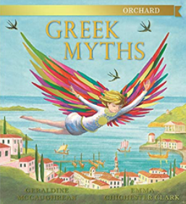 | Charlie & the chocolate factory by Roald Dahl  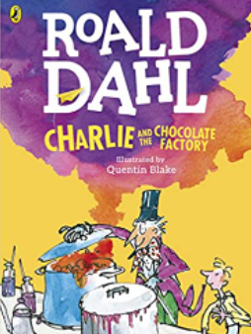 |  | Leon and the place between – Angella Mcallister & Graheme Baker -Smith  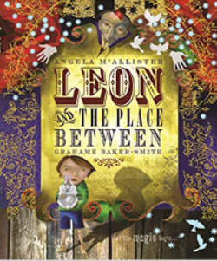 |  |  | The lost happy endings by Carol Ann Duffy  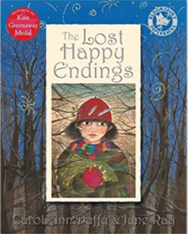 |  | Recount of Howard Carter’s discovery of Tutankhamen’s tomb |  |  | Gregory Cool by Caroline Binch  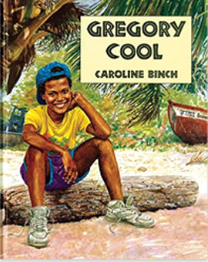
Unit outcome for best write books – action narrative  (Odysseus meets the cyclops, change next adventure he has on way back, create a new monster - needs to sound like a myth, focus on characterisation)  Audience: fellow travellers  Purpose: to entertain  Outcome: a story to be performed/re-told | Unit outcome for best write books – narrative  (Fifth character going into factory – write part of story when this character meets Willy Wonka, focus on characterisation)  Audience: peers  Purpose: to entertain  Outcome: new chapter in story |  | Unit outcome for best write books –narrative  (portal story –go from point where Leo enters box, comes back with something. Focus on setting)  Audience: young readers  Purpose: to entertain  Outcome: new event in a story |  |  | Unit outcome for best write books –suspense narrative  (fairy story –suspense writing for setting, interaction with a threat. Instead of encounters witch, meets something else in the forest)  Audience: readers  Purpose: to entertain  Outcome: new event in a story |  | Unit outcome for best write books –newspaper report  (discovery of tomb/after effects that it was cursed)  Audience: 1920s public  Purpose: to recount  Outcome: newspaper report |  |  | Unit outcome for best write books –action narrative & setting description  (setting description and action writing for when he encounters shark)  Audience: Gregory Cool readers  Purpose: to entertain  Outcome: new event
GPS links to be taught:  Reinforce consistently accurate use of punctuation from previous years, i.e. capital letters to start sentences and for proper nouns; full stops to end sentences; use of ? and !; commas for lists; use of inverted commas for speech.  Expansion after the noun, e.g. … guarded by vicious female monsters with boar fangs and hair of writhing and hissing snakes.  Use of wider range of conjunctions, e.g. when, if, because, although, until, so, but, as including those for time, e.g. Before he could react, he…. After the battle, he …  Use adverbials of manner, e.g. with a smile on his face…; with shouts of delight…; sick with fear…; struck dead with terror  Consolidate use of the present perfect tense from Y3, e.g. “I have warned you that defeat is not an option!” he growled.  Commas for fronted adverbials, e.g. After ten long years, Odysseus…  Use of possessive apostrophe for plural nouns, e.g. The men’s eyes widened in amazement. | GPS links to be taught:  Reinforce consistently accurate use of punctuation from previous years, i.e. capital letters to start sentences and for proper nouns; full stops to end sentences; use of ? and !; commas for lists; use of inverted commas for speech.  Build on narrative skills from autumn 1 plus…  Reinforce use of expanded noun phrase for precision, e.g. When he pressed the red button on the left of the machine, it..  Reinforce new speaker, new line rule for dialogue.  Reinforce use of comma for fronted adverbials, e.g. With a twinkle in his eye, he…  Choose pronouns.  appropriately, e.g. They stared at it in amazement. |  | GPS links to be taught:  Reinforce consistently accurate use of punctuation from previous years, i.e. capital letters to start sentences and for proper nouns; full stops to end sentences; use of ? and !; commas for lists; use of inverted commas for speech.  Build on narrative skills from autumn term plus…  Reinforce use of expanded noun phrases, e.g. a clown with a red nose and purple lips  Use wider range of adverbials for time, manner and place, e.g. In the next act, two acrobats soared through the air to the delighted gasps of the crowd.  Variation of sentence length for effect. |  |  | GPS links to be taught:  Reinforce consistently accurate use of punctuation from previous years, i.e. capital letters to start sentences and for proper nouns; full stops to end sentences; use of ? and !; commas for lists; use of inverted commas for speech.  Build on narrative skills from previous terms plus…  Continue to reinforce use of expanded noun phrases to build a picture, e.g. a twisted old woman with a face like the bark of a tree.  Continue to use dialogue to show characterisation, e.g. “I’ll have that!” she hissed, roughly snatching the sack from Jub’s shoulder.  Variation of sentence length for effect, e.g. sentence of 3 for pace: The witch bent down, snatched the sack and hobbled quickly away into the darkness. Use of short sentence: Jub was alone.  Use of imagery to build atmosphere, e.g. Scarves of mist hung from the trees. |  | GPS links to be taught:  Reinforce consistently accurate use of punctuation from previous years, i.e. capital letters to start sentences and for proper nouns; full stops to end sentences; use of ? and !; commas for lists; use of inverted commas for speech.  Expansion after the noun, e.g. a throne encrusted with jewels  Journalistic language, e.g. the incredible discovery  Use of wider range of conjunctions, e.g. when, if, because, although, until, so, but, as including those for time, e.g. Before the dig began, …  Use adverbials of time, manner and place, e.g. By early morning… with increasing excitement …across the city  Consolidate use of the present perfect tense from Y3, e.g. Archaeologists have discovered ….  Choose pronouns appropriately, e.g. It was an amazing discovery  Commas for fronted adverbials and clauses, e.g. Before Howard Carter could react...  Use of inverted commas for speech when using quotations, e.g. “I saw some wonderful things!” Mr Carter told us. |  |  | GPS links to be taught:  Reinforce consistently accurate use of punctuation from previous years, i.e. capital letters to start sentences and for proper nouns; full stops to end sentences; use of ? and !; commas for lists; use of inverted commas for speech.  Continue to develop characterisation through what characters say and do, e.g. “What can you do around here?” scowled Gregory, wiping the sweat from his forehead as he slumped down on a grass mound.  Use imagery appropriately to describe settings and build a picture for the reader, e.g. The turquoise sea sparkled like a jewel.  Use of possessive apostrophe for plural nouns, e.g. The fishermen’s eyes twinkled in amusement as they watched…  Continue to reinforce accurate use of pronouns.  .
Incidental writing along the journey  - What to look out for guide focusing on characterisation, e.g. If you meet this monster, beware of…  - Setting description with character and plot interwoven through setting description | Unit outcome for best write books – Persuasion  (Willy Wonka’s new product, in style of M&S food advert)  Audience: children  Purpose: to persuade  Outcome: advert in newspaper & script for TV/radio |  | Unit outcome for best write books – Instructional writing  (teach someone else a magic trick)  Audience: peers  Purpose: to instruct/inform  Outcome: a set of instructions |  |  | Unit outcome for best write books –recount  (diary entry – Jub or witch, hot seat both first)  Audience: a friend  Purpose: to recount  Outcome: diary entry |  | Range of non-fiction texts on mummification  Unit outcome for best write books –Instructional writing  Audience: trainee embalmer  Purpose: to instruct/inform  Outcome: leaflet |  |  | Unit outcome for best write books –Information text  (information guide on Caribbean islands)  Audience: Gregory Cool  Purpose: to inform  Outcome: pages from Lonely Planet guide
GPS links to be taught:  Reinforce skills as above where appropriate plus…  Use of third person, present tense to reinforce formal voice, e.g. The minotaur is usually found in…  Range of sentence types, including commands, e.g. Do not attempt to … | GPS links to be taught:  Reinforce skills as above where appropriate plus…  Use of second person to address audience directly, e.g. You will never forget your first bite of…  Expanded noun phrases, e.g. a delicious muesli bar covered with rich, dark chocolate and healthy hazelnuts.  Range of verb tenses, including modal (a Y5 objective but required for persuasion), e.g. You must give this a try! ; present progressive, e.g. this chocolate bar is taking the country by storm!  Exaggerated language to include comparatives and superlatives with word play, e.g. simply the smoothest smoothie on the market  Range of sentence types, including questions and commands, e.g. Do you dream of….? Don’t delay..  Adverbials of time, manner and place, e.g. Recently released across the UK, this chocolate bar will take you by surprise … |  | GPS links to be taught:  Reinforce skills as above where appropriate plus…  Use of adverbials for time, e.g. Before showing the card,… While they are looking at the card, …  Manner and place adverbials for precision and clarity, e.g. from the back of the pack; without hesitation;  Consolidate accurate and appropriate use of tenses taught so far, e.g. simple past and present; use of present progressive, e.g. As you are shuffling the cards; use of present perfect, e.g. After you have revealed the card… ; Use of imperative verbs, e.g. Shuffle the cards in front of the audience… |  |  | GPS links to be taught:  Reinforce skills as above where appropriate plus…  Consistent use of first person throughout  Range of devices to strengthen cohesion, e.g. fronted adverbials for time: Before I could react, the witch..; synonyms: The old hag snatched the sack..; pronouns: She appeared from nowhere… |  | GPS links to be taught:  Reinforce skills from spring 2 as above where appropriate plus…  Use language features from other text types to show progression, e.g. 3rd person, present tense for an information box about natron; second person present tense to directly address the reader etc.  Use wider range of verb tenses, including modal, e.g. If you follow this guide closely, you will… |  |  | GPS links to be taught:  Reinforce skills from previous non-fiction where appropriate plus…  Third person, present tense, e.g. These islands are located in…  Direct address to the reader where appropriate, e.g. If you are travelling to the city, make sure that  Continue to use wider range of conjunctions, including those for time, e.g. Before travelling to xxx, read this guide carefully.  Expanded noun phrases using positive language, e.g. This island is a jewel in the crown of the Caribbean.  Use of imagery where appropriate – but balanced with more formal tone in keeping with audience and purpose of the leaflet.  Use of subject-specific language, e.g. coastline, transport networks, watersports etc.  Reinforce use of apostrophe for plural possession, e.g. Tourists’ expectations will definitely be met.  Introduce adverbs for degree, e.g. It is highly likely; Tourists would be very unlucky if…
Incidental writing along the journey
- Poem – setting change tone from somewhere she feels comfortable to not. One verse = positive, one verse = negative. See discriptosaurus model
Year 5 & 6
Writing – transcription
Spelling - see English appendix 1
Pupils should be taught to:
- use further prefixes and suffixes and understand the guidance for adding them
- spell some words with ‘silent’ letters [for example, knight, psalm, solemn]
- continue to distinguish between homophones and other words which are often confused
- use knowledge of morphology and etymology in spelling and understand that the spelling of some words needs to be learnt specifically, as listed in English appendix 1
- use dictionaries to check the spelling and meaning of words
- use the first 3 or 4 letters of a word to check spelling, meaning or both of these in a dictionary
- use a thesaurus
Writing - composition
Pupils should be taught to:
- plan their writing by:
- identifying the audience for and purpose of the writing, selecting the appropriate form and using other similar writing as models for their own
- noting and developing initial ideas, drawing on reading and research where necessary
- in writing narratives, considering how authors have developed characters and settings in what pupils have read, listened to or seen performed
- draft and write by:
- selecting appropriate grammar and vocabulary, understanding how such choices can change and enhance meaning
- in narratives, describing settings, characters and atmosphere and integrating dialogue to convey character and advance the action
- précising longer passages
- using a wide range of devices to build cohesion within and across paragraphs
- using further organisational and presentational devices to structure text and to guide the reader [for example, headings, bullet points, underlining]
- evaluate and edit by:
- assessing the effectiveness of their own and others’ writing
- proposing changes to vocabulary, grammar and punctuation to enhance effects and clarify meaning
- ensuring the consistent and correct use of tense throughout a piece of writing
- ensuring correct subject and verb agreement when using singular and plural, distinguishing between the language of speech and writing and choosing the appropriate register
- proofread for spelling and punctuation errors
- perform their own compositions, using appropriate intonation, volume, and movement so that meaning is clear
Writing - vocabulary, grammar and punctuation
Pupils should be taught to:
- develop their understanding of the concepts set out in English appendix 2 by:
- recognising vocabulary and structures that are appropriate for formal speech and writing, including subjunctive forms
- using passive verbs to affect the presentation of information in a sentence
- using the perfect form of verbs to mark relationships of time and cause
- using expanded noun phrases to convey complicated information concisely
- using modal verbs or adverbs to indicate degrees of possibility
- using relative clauses beginning with who, which, where, when, whose, that or with an implied (ie omitted) relative pronoun
- learning the grammar for years 5 and 6 in English appendix 2
- indicate grammatical and other features by:
- using commas to clarify meaning or avoid ambiguity in writing
- using hyphens to avoid ambiguity
- using brackets, dashes or commas to indicate parenthesis
- using semicolons, colons or dashes to mark boundaries between independent clauses
- using a colon to introduce a list
- punctuating bullet points consistently
- use and understand the grammatical terminology in English appendix 2 accurately and appropriately in discussing their writing and reading
Year 5

Autumn 1 | Autumn 2 |  | Spring 1 |  |  | Spring 2 |  | Summer 1 |  |  | Summer 2
Tuesday by David Weisner  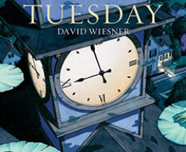 | The boy in the tower by Polly Hoe-Yen  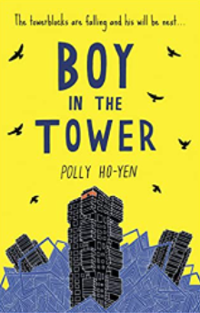 |  | Wonder by R J Palicio  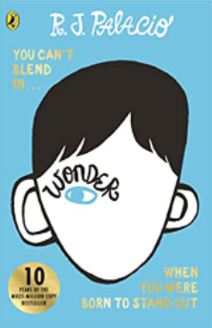 |  |  | The Explorer by Katherine Rundell 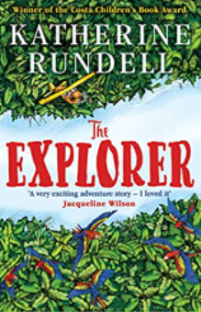 |  |  |  | Beowulf by Michael Morpurgo  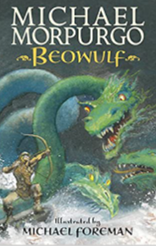
Unit outcome for best write books – recount  (Diary entry from different perspective, e.g. policeman, old lady etc)  Audience: an interested listener  Purpose: to recount  Outcome: diary entry | Unit outcome for best write books – report  (report on creatures)  Audience: an expert  Purpose: to inform Outcome: letter |  | Unit outcome for best write books – narrative  (new event for story focus on chyaracterisation)  Audience: readers of Wonder  Purpose: to entertain  Outcome: new event |  |  | Unit outcome for best write books – Instructional text  (guide on how to survive in the rainforest)  Audience: travellers  Purpose: to instruct/inform  Outcome: survival guide |  |  |  | Unit outcome for best write books – action narrative  (Beowulf encounters Grendle for first time - change Grendal to own monster)  Audience: peers Purpose: to entertain  Outcome: an action scene
GPS links to be taught:  Reinforce consistently accurate use of punctuation from previous years, i.e. capital letters to start sentences and for proper nouns; full stops to end sentences; use of ? and !; commas for lists and to mark phrases and clauses; use of parenthesis  Some expansion after the noun, e.g. a lake as smooth as glass  Consolidate use of verb forms from previous years, e.g. I had just settled down to watch xxxx on TV, when I …. Flying faster and faster, the frogs whooped with delight…  Use of wider range of verb forms, e.g. modal: Could this really be happening?  Reinforce use of range of adverbials of time, manner and place, e.g. As dawn’s first rays streaked the sky…With croaks of delight.. Across the night sky…over houses and gardens…  Consolidate use of appropriate conjunctions from previous year groups, e.g. when, if, because, although, until, so, but, as including those for time, e.g. Before I could react, they…. They soared across the night sky until …  Reinforce use of relative clauses to provide extra information, e.g. Mr Brown, who was driving home from work, reported that…  Reinforce punctuation for parenthesis, e.g. The dog, exhausted and panting, gave up the chase…  Introduce reported speech (if appropriate to the outcome), e.g. Mrs Dingle stated that she was unaware of the drama unfolding outside.  If recount is a more formal police report, ensure that more formal cohesive devices are used, e.g. Furthermore, Mrs Turner believes that the frogs are responsible for…Consequently, Mrs Turner insists that compensation should be offered… | GPS links to be taught:  Reinforce consistently accurate use of punctuation from previous years, i.e. capital letters to start sentences and for proper nouns; full stops to end sentences; use of ? and !; commas for lists and to mark phrases and clauses; use of parenthesis.  Some expansion after the noun, e.g. a thick brown stem with multiple thorns capable of causing serious injury  Consistent use of third person and present tense for objective, formal voice.  Technical vocabulary to add precision e.g. photosynthesis, chlorophyl  - Conditional and hypothetical (if/then) sentences e.g. If approached, the plant will…  Expand use of conjunctive adverbs, e.g:  - Similar points, e.g. They use their branches to; in the same way, they use their roots to….  - Additional points, e.g. These plants are often quite solitary; furthermore, due to their aggressive nature…  - Opposite points, e.g. They mostly hunt in pairs; however, some prefer…  - Summarising phrases, e.g. In short, if you spot…  Introduce use of semicolon as used in above sentences.  Use of parenthesis with brackets, commas or dashes, e.g. The deadly Hogweed (Piggus Giganticus) is found…; Its leaves, which feel like sandpaper, are made up of tiny teeth-like structures |  | GPS links to be taught:  Reinforce consistently accurate use of punctuation from previous years, i.e. capital letters to start sentences and for proper nouns; full stops to end sentences; use of ? and !; commas for lists and to mark phrases and clauses; use of inverted commas for speech; use of parenthesis  Continue to build on skills taught in autumn term plus  Some expansion after the noun to indicate character, e.g. … The headteacher was bald, with a thin, angular face which gave him a skull-like appearance.  Some appropriate use of imagery to show emotion, e.g. eyes – slits of fury; guilt – like a lead ball like his stomach  Use of dialogue to advance the action, e.g. “And just where do you think you’re going?” he jeered, barring the entrance to the door.  Use wide range of verb forms with increasing accuracy.  Use of relative clauses, e.g.  Auggie, who had always been taught to be polite, struggled to remain calm.  Use of commas and dashes for parenthesis, e.g. Auggie, his hearing aids lost in the scuffle, now felt very vulnerable. Auggie glanced at the door – it was now or never… |  |  | GPS links to be taught:  Reinforce consistently accurate use of punctuation from previous years, i.e. capital letters to start sentences and for proper nouns; full stops to end sentences; use of ? and !; commas for lists and to mark phrases and clauses; use of parenthesis  Expanded noun phrases to convey information precisely, e.g. The Amazon rainforest is a hot, humid- and often hostile environment.  Use of precise nouns, e.g. Many mammals, such as howler monkeys and sloths…  Range of verb tenses, e.g. Imperative: Find a clearing in which to construct a shelter; past perfect: If you have prepared thoroughly…; Finite verbs: Moving slowly through undergrowth is essential…; passive: the forest floor is littered with…; modal: You must ensure that…  Use of second and third person and passive voice for informal/formal tone where appropriate in the text, e.g. You should prepare thoroughly… The Amazon rainforest is often referred to as the ‘lungs of the world’.  Reinforce conditional/hypothetical sentence structures, e.g. If the xxxx senses movement, it will immediately..  Use a wide range of conjunctions from previous year groups to create multi-clause sentences where appropriate.  Reinforce use of conjunctive adverbs from spring term, e.g:  - Similar points, e.g. They use their leaves to; in the same way, they use their roots to….  - Additional points, e.g. These monkeys are often quite solitary; furthermore, due to their aggressive nature…  - Opposite points, e.g. They mostly hunt in pairs; however, some prefer…  - Summarising phrases, e.g. In short, if you spot…  Reinforce use of semicolon in above sentences.  Reinforce use of colon and semicolons to introduce a list, e.g. Certain items are essential: a compass (with a lanyard for ease of transport); a guide book with easy-to-read maps; etc.  Adverbials for clarity and precision, e.g. a deep incision from one corner to the other… etc.  Use of parenthesis, e.g. When threatened, no matter whether it is a large animal or a human, bullet ants will sting repeatedly.  . |  |  |  | GPS links to be taught:  Reinforce consistently accurate use of punctuation from previous years, i.e. capital letters to start sentences and for proper nouns; full stops to end sentences; use of ? and !; commas for lists and to mark phrases and clauses; use of inverted commas for speech.  Some expansion after the noun to convey complicated information concisely, e.g. Beowulf peered into the blanket of mist prowling across the moorland.  Consolidate use of verb forms from previous years, e.g. He had always dreamt of defeating Grendel and victory was finally in his grasp.  Use of wider range of verb forms, e.g. modal: Could this really be happening?  Use of wider range of cohesive devices, e.g. The next minute was the longest of his life…;  Consolidate use of appropriate conjunctions from previous year groups, e.g. when, if, because, although, until, so, but, as including those for time, e.g. Before he could react, he…. Beowulf grabbed Grendel’s arm, twisting it forcefully until the beast howled in pain.  Expand range of adverbials of time, manner and place, e.g. Without a second’s hesitation, he…; with panic rising in his chest, he..…; on the far side of the hall  Use of dialogue to show characterisation.  Introduce punctuation for parenthesis, e.g. use of commas: Grendel, sick with rage, lashed out furiously; use of dashes: Beowulf – his quest accomplished – returned as a hero.  Vary sentence length for effect to show pace, e.g. It lunged. He swerved
Unit outcome for best write books – fantasy narrative  (sequel to book)  Audience: David Weisner fans  Purpose: to entertain  Outcome: short story | Unit outcome for best write books – recount  (oral broadcast – focus on journalistic language)  Audience: concerned citizens  Purpose: to inform and warn  Outcome: script for a TV broadcast |  |  |  |  | Unit outcome for best write books – persuasive text  (Advertising adventure holiday for intrepid explorers to visit the rainforest)  Audience: explorers  Purpose: to persuade  Outcome: brochure |  |  |  | Unit outcome for best write books – newspaper report  (Beowulf’s victory)  Audience: Viking citizens  Purpose: to recount  Outcome: newspaper report
GPS links to be taught:  Continue to build on narrative skills from autumn 1 | GPS links to be taught:  Continue to build on journalistic skills from autumn 1 term plus…  Direct address to the listener/viewer with a more informal tone. |  |  |  |  | GPS links to be taught:  Reinforce skills as above where appropriate plus…  Expanded noun phrases with hyphens, e.g. a once-in-a-lifetime-opportunity  Use of wider range of verb forms, e.g. modal: Everybody should have the opportunity to…; You must visit this…  Adverbs to show possibility or degree, e.g. It is highly likely that..Surely you can understand why…  Use of relative clauses to embed information, e.g. Our rainforest tribe excursions, which are open to all ages, are always very popular.  . |  |  |  | GPS links to be taught:  As above (where appropriate) plus…  3rd person formal language  Range of tenses used, e.g. past progressive: As Beowulf was entering the mead hall…; past perfect: Beowulf had prepared well…present progressive: Our citizens are celebrating his great victory  Introduce use of relative clauses, e.g. Beowulf, who defeated the creature unarmed, has been declared a national hero.  Journalistic language, e.g. epic battle
 |  |  |  |  |  | Unit outcome for best write books – biography  (biography of Steve Backsahll)  Audience: National Geographic reader  Purpose: to recount  Outcome: article |  |  |  | Incidental writing along the journey Characterisation (describe the character they’ve created)
 |  |  |  |  |  | GPS links to be taught:  As above where appropriate plus…  Use wider range of verb tenses appropriately within and across sentences, e.g. Now one of TV’s busiest presenters, Steve has recently finished filming his latest BBC series xxxx and will shortly be seen again in his new ITV documentary xxxx.  Expanded noun phrases to convey information precisely, e.g. …to indulge his ever-growing passion for the natural world  Cohesive adverbials to link sentences and paragraphs, e.g. At the age of…; Two years later…; Years passed before…etc |  |  |  | GPS links to be taught: As above where appropriate
Year 6
Autumn 1 | Autumn 2 |  | Spring 1 |  |  | Spring 2 |  | Summer 1 |  |  | Summer 2
When the sky falls by Phil Earle  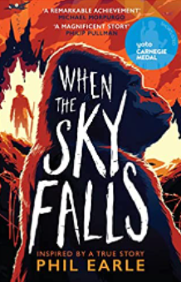 | When the sky falls by Phil Earle |  | Wallace & Gromit – The complete cracking contraptions manual  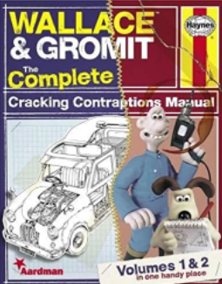 |  |  | Wolves of Willoughby Chase by Joan Aiken  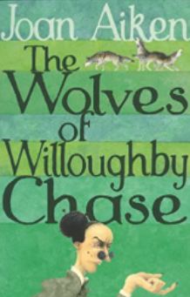  Uncle Monatgue’s Tales of Terror by Chris Priestly  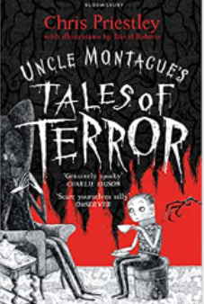 |  | Spiderwick Chronicles Field Guide by Toni DiTerlizzi  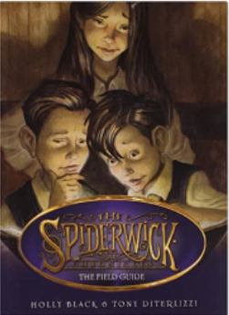  Fantastic Beasts and where to find them by JK Rowling  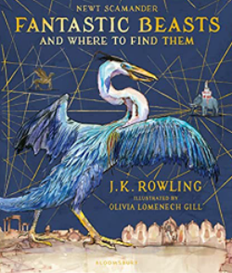
Unit outcome for best write books – persuasive text  (come and join the land army/RAF)  Audience: citizens  Purpose: to inform Outcome: information leaflet/script for radio advert | Unit outcome for best write books – narrative  (letter to a friend – what he’s missed, wishing being back in London etc if doing main character; not everyone doing same character though, do Mrs F writing to a friend to about him coming to stay)  Audience: a friend  Purpose: to recount  Outcome: a letter |  | Unit outcome for best write books – explanation  (page has been ripped out of the book, chdn create it)  Audience: readers  Purpose: to explain Outcome: page from the book |  |  | Unit outcome for best write books – suspense narrative  (atmospheric writing)  Audience: nephew  Purpose: to terrify Outcome: short story |  | Unit outcome for best write books – Information text  (writing to Natural History Museum as a new creature has been discovered and asking for advice)  Audience: Natural History Museum  Purpose: to inform  Outcome: a formal letter
GPS links to be taught:  Reinforce consistently accurate use of punctuation from previous years, i.e. capital letters to start sentences and for proper nouns; full stops to end sentences; use of ? and !; commas for lists and to mark phrases and clauses; use of inverted commas for speech; use of bracket, commas and dashes for parenthesis; use of colons and semicolon for lists; use of semicolon after conjunctive adverbs, e.g. however, whereas etc.  Expanded noun phrase to convey information concisely, e.g. a never-to-be-forgotten opportunity to help your country.  Consolidate use of verb forms from previous years, e.g. Farmers have been the backbone of Britain for centuries…  Use of wider range of verb forms, e.g. modal: Every citizen should be prepared to contribute to the war effort; Imperative: You must act immediately to prevent…  Adverbs to show possibility or degree, e.g. It is highly likely that..Surely you can understand why…  Use of relative clauses to embed information, e.g. The security of our food supply, which is essential to our success in the war, must be protected.  Use of more formal language, e.g. nominalisation: the security of our country is paramount; our success depends on your contribution…  Use range of cohesive devices, e.g. conjunctive adverbials for:  -Additional points, e.g. What’s more Additionally..Also  -Similar points, e.g. Equally…  -Opposite points, e.g. In contrast..however  -Transition phrase, e.g. As far as xxx is concerned…  -Results, e.g. For this reason, we must…In short,…  Use of repetition and synonyms.  Consolidate use of appropriate conjunctions from previous year groups, e.g. when, if, because, although, until, so, but, as including those for time, e.g. until, before, after etc. | GPS links to be taught:  Reinforce consistently accurate use of punctuation from previous years, i.e. capital letters to start sentences and for proper nouns; full stops to end sentences; use of ? and !; commas for lists and to mark phrases and clauses; use of parenthesis  Refer to Y5 recount GPS to ensure progression of skills.  Consistent use of first person throughout.  Adverbials of time, manner and place.  Range of sentence types and length for effect.  Expanded noun phrases to convey information concisely, e.g. At my age, I didn’t expect to be landed with a rude boy with such an appalling attitude! Consolidate use of verb forms from previous years, e.g.: You wouldn’t believe where I’ve ended up and I’m furious! I just hate the fact that decisions are being made for me and I’ve got no control.  Use of informal language features, e.g. contracted form; idioms: Mrs F is a real pain; phrasal verbs: I can’t put up with this for much longer; question tags: It’s just unfair, isn’t it?  Consolidate use of appropriate conjunctions from previous year groups, e.g. when, if, because, although, until, so, but, as including those for time. |  | GPS links to be taught:  Reinforce consistently accurate use of punctuation from previous years, i.e. capital letters to start sentences and for proper nouns; full stops to end sentences; use of ? and !; commas for lists and to mark phrases and clauses; use of bracket, commas and dashes for parenthesis; use of colons and semicolon for lists; use of semicolon after conjunctive adverbs, e.g. however, whereas etc.  Expansion after the noun to convey complicated information concisely e.g. turn the red dial located on the left-hand side of the control panel.  Technical vocabulary.  Mainly present tense but some use of passive to maintain formal voice, e.g. The lever is attached to the base.  Relative clauses to embed extra information, e.g. the pad, which is located on the base of the machine, is weight-sensitive.  Subordinating conjunctions to expand upon independent clauses, e.g. Since the balloon is large in size, two people are needed to hold it down. The balloon is filled until it is rounded and stretched.  Causal conjunctions, e.g. e.g. results in, in order to, this allows, due to etc.  Evaluative adverbs, e.g. incredibly, amazingly, weirdly  Use of wider range of cohesive devices, e.g. furthermore, in addition,  consequently |  |  | GPS links to be taught:  Reinforce consistently accurate use of punctuation from previous years, i.e. capital letters to start sentences and for proper nouns; full stops to end sentences; use of ? and !; commas for lists and to mark phrases and clauses; use of inverted commas for speech; use of bracket, commas and dashes for parenthesis; use of colons and semicolon for lists; use of semicolon after conjunctive adverbs, e.g. however, whereas etc.  Continue to build on narrative skills from spring term.  Varying sentence length for effect.  Variation of sentence starters.  Noun phrases with controlled use of imagery to describe settings and create atmosphere, e.g. Scarves of mist hung from the trees.  Wider range of cohesive devices to encourage flow, e.g. repetition: He had to get back. He had to get out - now!  Wider range of verb forms for effect, e.g. I ran hard, not looking at the house, not looking at the faces of those who stared, not even looking at the road ahead.  Some use of passive, e.g. the furniture was covered in a thick layer of dust.  Use adverbials of time, manner and place, e.g. Without a second’s hesitation, he…; with panic rising in his chest, he..…; on the far side of the hall Adverbs to show degrees of probability, e.g. Surely help would arrive soon?  Consolidate use of appropriate conjunctions from previous year groups, e.g. when, if, because, although, until, so, but, as including those for time, e.g. Before he could react, he…. He grabbed an arm, twisting it forcefully until the beast howled in pain.  Reinforce punctuation for parenthesis, e.g. use of commas: xxxx, sick with rage, lashed out furiously; use of dashes: xxxx – filled with dread –turned to face the intruder.  Reinforce use of the colon for effect, e.g. XXXX had just one goal in mind: to get out alive.  Dialogue to advance the action. |  | GPS links to be taught:  Reinforce consistently accurate use of punctuation from previous years, i.e. capital letters to start sentences and for proper nouns; full stops to end sentences; use of ? and !; commas for lists and to mark phrases and clauses; use of inverted commas for speech; use of bracket, commas and dashes for parenthesis; use of colons and semicolon for lists; use of semicolon after conjunctive adverbs, e.g. however, whereas etc.  Continue to build on non-fiction writing from autumn term.  Noun phrases to combine information concisely, e.g. Another distinguishing feature is its strong tail, which is used for propulsion through water.  Expand use of conjunctive adverbs, e.g:  - Additional points, e.g. They use their fins to power their way through water; in the same way, they use their snout to….  - Similar points, e.g. These creatures appear quite solitary; furthermore, due to their aggressive nature…  - Opposite points, e.g. They mostly hunt in pairs; however, some prefer…  - Summarising phrases, e.g. In short, identification is easy because..  Maintain a formal voice throughout, i.e. avoid contractions; use abstract nouns, e.g. its ability to move at speed through water is impressive; use of passive, e.g. xxxx are born in shallow water  Use of parenthesis with brackets, commas or dashes, e.g. The common xxxxx (Latin name) is found…; Its skin, which feels like sandpaper, is made up of tiny teeth-like structures
Unit outcome for best write books – Instructional text  (Government guidance – what to do in an air raid)  Audience: citizens  Purpose: to instruct/inform Outcome: persuasive leaflet/script for radio broadcast | Incidental writing along the journey  - Characterisation (character who Joseph has interaction with – chdn pick up on clues in text and describe = not all doing the same). |  | Unit outcome for best write books – persuasion  (buy a child’s toy)  Audience: parents  Purpose: to persuade Outcome: persuasive leaflet/radio advert |  |  |  |  | Incidental writing along the journey  Top trumps for creature they’re creating
GPS links to be taught:  Build on skills taught in Y5 plus  Maintain a formal voice throughout using:  Expanded noun phrases to convey information concisely, e.g. This is the signal that tells you that danger has passed.  Use of abstract nouns, e.g. The government is taking all measures necessary for the defence of your country and for your protection.  Range of verb forms, e.g. Imperative: Listen for the all-clear which consists of …; modal: You must follow these instructions carefully; passive: Further guidance will be issued if…  Adverbs of manner, e.g. Carefully plan…; Strategically link…. And time, e.g. When the air-raid siren sounds… | GPS links to be taught:  Continue to reinforce narrative skills from Y5 with focus on  Expanded noun phrases to combine information, e.g. He was bald, with a thin, angular face and pursed lips which suggested disapproval.  Use adverbials of time, manner and place, e.g. As the minutes passed, he began to grow more and more frustrated…, He … with a broad grin on his face…; on the far side of the platform  Use of relative clauses to embed information, e.g. Mrs F, who had witnessed the argument, strode across the platform…  Use brackets and commas to indicate parenthesis , e.g Snatching his arm away angrily, Joseph turned to face Mrs F. (Inside, however, he was fighting the urge to cry.)  Use of inverted commas for speech and to advance the action, e.g. “Get your hands off me! I ain’t done nothin’?” he shouted, snatching his arm away angrily. (Use formal/informal language for dialogue depending on character.) |  | GPS links to be taught:  Expanded noun phrases to convey information concisely, e.g. this toy has several unique features, cleverly designed to appeal to curious minds… and for exaggeration, e.g. a never-to-be-repeated offer  Use of wider range of verb forms, e.g. modal: Every child should have the opportunity to…; You must act immediately to secure…; imperative, e.g. Sign up for this special offer now!  Active voice: We have sold thousands of…  Personal pronouns, e.g. You and your family deserve…  Adverbs to show possibility or degree, e.g. It is highly likely …Undoubtedly, this is an opportunity which cannot be missed…  Use of relative clauses to embed information, e.g. The xxx, which has been designed with young children in mind, will…  Use range of cohesive devices, e.g. conjunctive adverbials for:  -Additional points, e.g. What’s more… Additionally..Also  -Similar points, e.g. Equally…  -Opposite points, e.g. In contrast..however  -Transition phrase, e.g. As far as xxx is concerned…  -Results, e.g. For this reason, you must…In short,….  Synonyms and repetition  Variation of sentence length and type for effect, e.g. Act fast. Act now.; Are you looking for…?  Use of semi-colon, e.g. Our prices are the lowest in the UK; you’ll spend forever looking for a better deal. |  |  |  |  | GPS links to be taught:  Reinforce GPS skills as above
Unit outcome for best write books – Biogrpahy  (Adolf Hitler/Churchill)  Audience: readers  Purpose: to recount Outcome: an article | Unit outcome for best write books – Action narrative  (Action scene of Joseph being somewhere else when air raid siren goes off)  Audience: readers  Purpose: to describe Outcome: new event |  |  |  |  |  |  | Unit outcome for best write books – Instructional writing  (How to care for new creature)  Audience: child with a pet  Purpose: to instruct/inform  Outcome: a leaflet
GPS links to be taught:  Continue to build on recount skills from Y5 plus..  Use a wider range of verb tenses appropriately within and across sentences.  Expanded noun phrases to convey information precisely, e.g. …as a result of his ever-growing resentment of…  If a formal tone is required, use passive voice, e.g. Little is known about…; and abstract nouns, e.g. The antipathy shown towards…  Cohesive adverbials to link sentences and paragraphs, e.g. At the age of…; Two years later…; Years passed before…etc | GPS links to be taught:  Reinforce consistently accurate use of punctuation from previous years, i.e. capital letters to start sentences and for proper nouns; full stops to end sentences; use of ? and !; commas for lists and to mark phrases and clauses; use of inverted commas for speech.  Use of wider range of verb forms, e.g. modal: Could this really be happening?  Use of wider range of cohesive devices, e.g. The next minute was the longest of his life…;  Consolidate use of appropriate conjunctions from previous year groups, e.g. when, if, because, although, until, so, but, as including those for time, e.g. Before he could react, he…. .  Expand range of adverbials of time, manner and place, e.g. Without a second’s hesitation, he…; with panic rising in his chest, he..…;  Use of dialogue to show characterisation and to advance the action.  Reinforce punctuation for parenthesis, e.g. use of commas: Joseph, sick with fear, raced towards the zoo; He stared at the open cage – he was too late.  Vary sentence length for effect to show pace, e.g. It lunged. He swerved. |  |  |  |  |  |  | GPS links to be taught:  Reinforce GPS skills taught in autumn 1 but with more of an informal, engaging tone to appeal to a young audience.  Use subject-specific vocabulary from information text earlier in this unit.

